KEY TOOLS PORTFOLIO FOR SERVITIZATION OF CE PRODUCT-BASED MANUFACTURING COMPANIES

Phase 2 - revised

|  |  |
| --- | --- |
| **D.T3.2.5** | **Version 1**  **3 2019** |

THINGS+

Introducing service innovation into product-based manufacturing companies

01.06.2017 - 31.05.2020

Project number: CE 988

Interreg Central Europe Programme

|  |  |  |  |  |  |
| --- | --- | --- | --- | --- | --- |
| Work package | T3 | Activity | A.T3.2 | Deliverable | D.T3.2.5 |
| Date | March 26th 2019 | | | Due date | March 2019[1] |
| Title | Key tools portfolio for servitization of CE product-based manufacturing companies – Phase 2 | | | | |
| Project Partner responsible | All partners | | | | |
| Report Status (DR = Draft, FI = Final) | | | | FI | |
| THINGS+ website | http://www.interreg-central.eu/Content.Node/THINGS-.html | | | | |

Contents

1. Phase 2: Opportunities based on external developments and new insights – outside-in 2

1.1. Customer segments list & description(s) 4

1.2. Customer Persona (per segment) 6

1.3. Customer Journey(s) (per segment) 10

1.4. Servitization opportunities 14

1.5. Prioritized Opportunities (Company Perspective) 17

1.6. Servitization concept 19

1. Phase 2: Opportunities based on external developments and new insights – outside-in

This document contains a set of tools to be used during the second phase of implementing the Service Innovation Methodology. The participating SMEs will revise their assumptions in the period after the workshop, based on new customer insights. The companies will be instructed how to use these tools for self-assessment and data gathering, and also will be supported and mentored by the project staff if needed.

This second phase of implementation engages more in-depth analysis of the targeted customer and the problem they are trying to solve. The aim is to introduce companies with as much “outside” knowledge and customer centric perspective possible, so the most valuable servitization opportunities can be recognized. For this purpose, after the workshop companies will be assigned with using tools to document and assess new insights based on direct interaction with their customer segment.

The workflow of the second phase is presented in the following scheme.

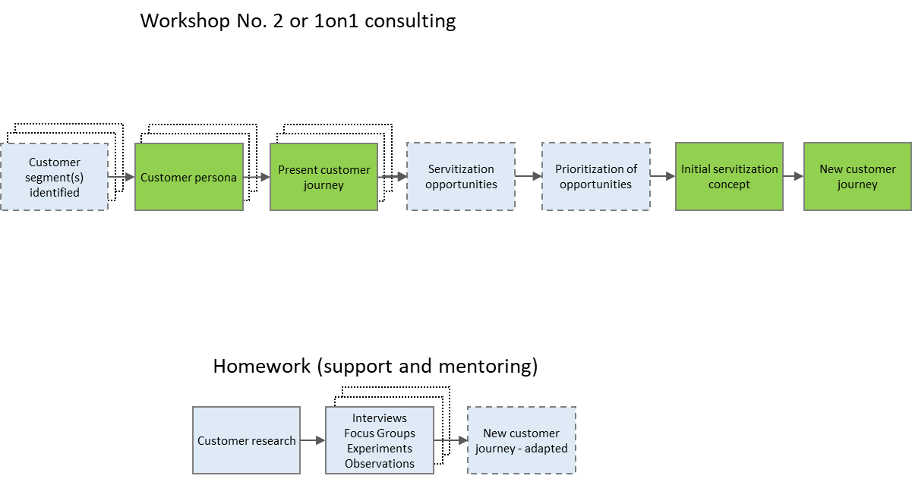

Figure 1 Workflow of the second phase of the Service Innovation Methodology

* 1. Customer segments list & description(s)

|  |  |
| --- | --- |
| **Companies should identify customer segments and then gradually shift the perception of them beyond the existing assumptions. Demographic, social and other features of customer segments should be documented in order to understand where to find them and who to target, and also how to adapt servitized offering. Since customer segments are already identified in the first phase (JTBD) this tool is optional and can be used for further assessment.** | |
| **Guidelines on implementation:** | **D.T1.3.1 - Phase 2 – Workshop** |

This tool serves as an addition to Customer problem/Jobs to be done description. Customer segmentation is the practice of dividing a customer base into groups of individuals with common characteristics or similarities in a specific way (age, gender, interests, habits, income), which can then be targeted with a specific value proposition. Customer segmentation relies on identifying key differentiators that divide customers into target groups. Companies need to divide their customers into measurable segments according to their needs, behaviours or demographics and also aim to determine the profit potential of each segment by analysing its revenue and cost impacts. Value-based segmentation evaluates groups of customers in terms of the revenue they generate and the costs of establishing and maintaining relationships with them. Company needs to understand how its best current customers are segmented so it knows how to allocate and spend its human and capital resources efficiently. While conducting the customers segments from a customer list or database, it should be considered not to take into account certain marginal customers that are positioned on the extremes of the customer base, determined by either revenue or deal structure.

The goal is to determine what makes a good customer for a company or product, which is often determined by the customer value - the total net present value of the cumulative profits generated by a customer over its lifetime.

Also, it is important to outline the way each customer segment is buying and using the product, not only to identify similarities and differentiators between the groups, but also to find the group that is most appropriate to be targeted with new value proposition.

|  |  |
| --- | --- |
| **Additional sources:** | * <http://www.thebridgecorp.com/customer-segmentation/> * <http://searchsalesforce.techtarget.com/definition/customer-segmentation> * <https://labs.openviewpartners.com/customer-segmentation/#.WplFTejwaUk> |

|  |  |  |
| --- | --- | --- |
| **Product**: | | |
| Customer segment  (buyer or user)  **Who is our customer?** | Demographics, social, geographical… characteristics  **Where? Who?** | Time, place, sales, marketing and distribution channels  **How to buy and use?** |
|  |  |  |
|  |  |  |
|  |  |  |

* 1. Customer Persona (per segment)

|  |  |
| --- | --- |
| **After previous customer segment analysis, the focus should be directed to the most promising customer segment(s). It is suggested to proceed with no more than three customer segments. The aim is to describe the customer based on a specific individual – a real person representing the customer segment. Description includes every information available that will enable understanding of that particular segment beyond usual moments of interaction with company (buy/use/complaint), like: personal detail, demographics, social status, preferences and values, quotes or requests, etc. This information should enable to identify even more precisely who to target, when and how.** | |
| **Guidelines on implementation:** | **D.T1.3.1 - Phase 2 – Workshop** |

Customer personas are fictional profiles developed as a way of representing a particular group based on their shared interests. Personas are created with a combination of raw data and educated guesses and building them can help improve the way of solving challenges.

The most common way of developing a persona is to collate research insights into common-interest groupings, which can then be developed into a workable “character”. Designer needs to collect information about the intended users, by doing qualitative research, using context-mapping techniques, interviews and observations.

Effective personas can shift focus away from abstract demographics, and towards the wants and needs of real people. Even though personas themselves are mostly fictional, the motivations and reactions they present are real, based on the feedback elicited during the research stage of the project, and as such embody the real-world perception surrounding a company’s service.

Personas help understand the customers (and prospective customers) better. This makes it easier to tailor the content, messaging, product and services development to the specific needs, behaviours, and concerns of different groups.

Some practical methods for gathering the information needed to develop personas are:

* Looking through the contacts database to uncover trends about how certain leads or customers find and consume content,
* Using form fields in website forms that capture important persona information,
* Take into consideration sales team's feedback on the leads they're interacting with most,
* Interviewing customers and prospects, either in person or over the phone, to discover what they like about the product or service.

Personas cannot be used as an independent evaluation tool, therefore, the real people are needed to test and evaluate the offering.

|  |  |
| --- | --- |
| **Additional sources:** | * Stickdorn, M.; Schnaider, J.; et al.: This is service design thinking, John Wiley & Sons, Hoboken, New Jersey, 2011 * https://blog.bufferapp.com/marketing-personas-beginners-guide * https://blog.hubspot.com/blog/tabid/6307/bid/33491/Everything-Marketers-Need-to-Research-Create-Detailed-Buyer-Personas-Template.aspx |

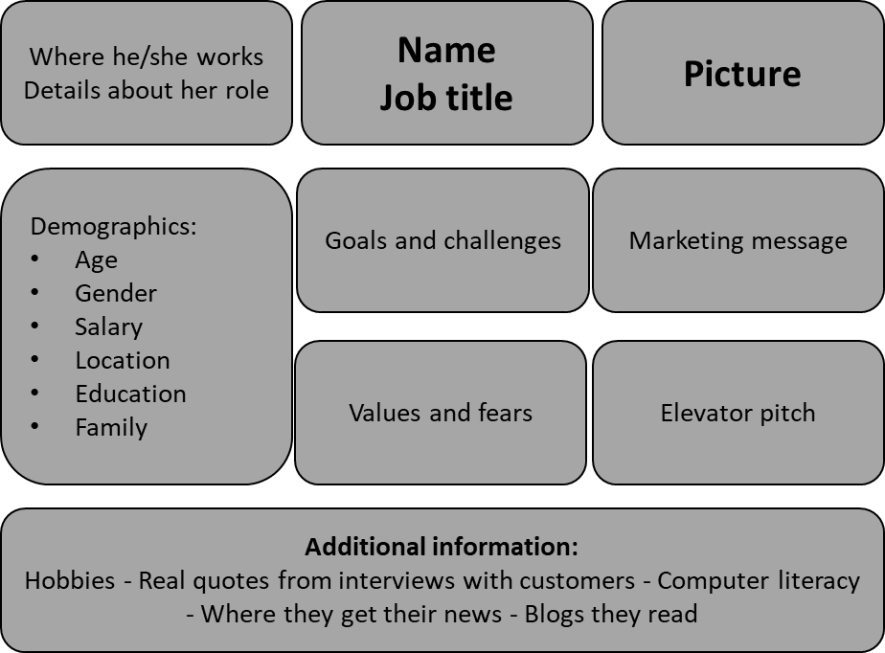

Figure 2 Example template of a Customer Persona

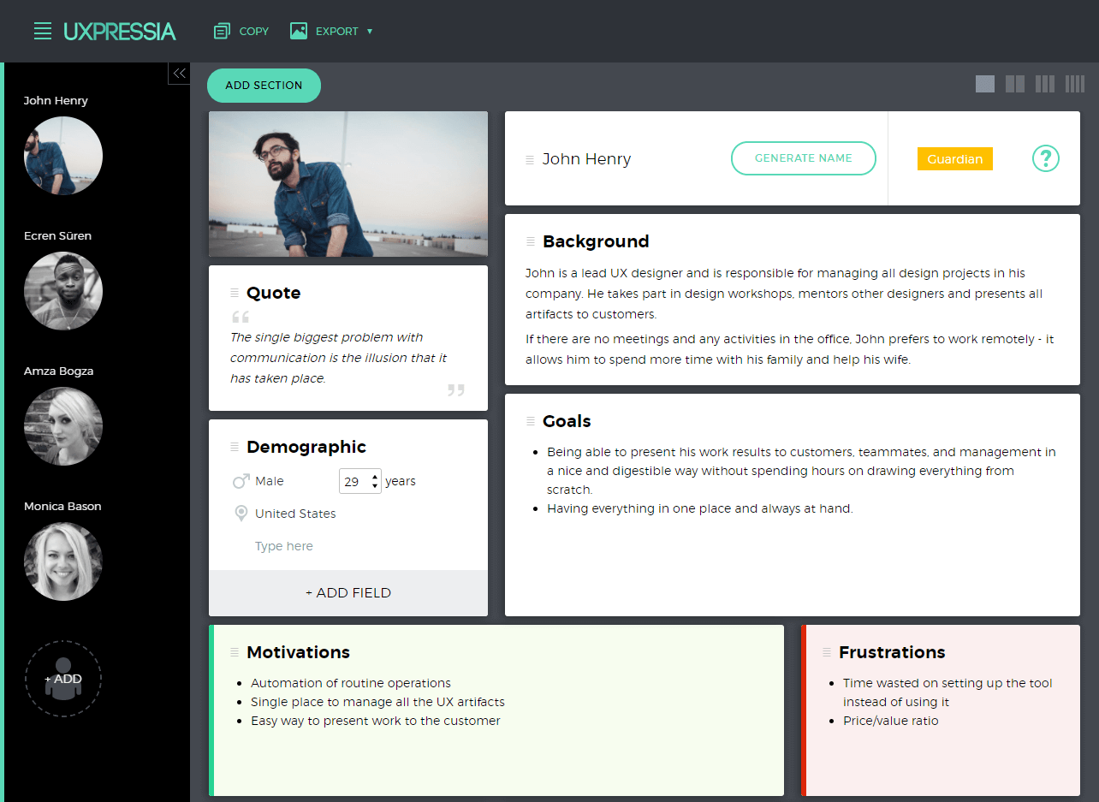

Figure 3 Example of a filled-out Customer Persona (source: https://www.smashingmagazine.com)

**Customer Persona template A**

|  |  |  |
| --- | --- | --- |
| **Work description**  **Role details** | **Name**  **Job title** | **Picture** |
| **Demographics** | **Goals and challenges** | **Marketing** |
| **Values and fears** | **Elevator pitch** |
| **Additional information** | | |

**Customer Persona template B**

|  |  |  |
| --- | --- | --- |
| **Name**  **Descriptive** | **Likes** | **Service** |
| **Dislikes/frustrations** | **Product** |
| **Routines** | | **Others** |

* 1. Customer Journey(s) (per segment)

|  |  |
| --- | --- |
| **This tool is used to visually capture the entire cycle of customer’s experience from the moment the customer’s problem emerges until after the solution is applied. Stages of the journey can be generic (preparation, purchase, delivery, use, supplements, maintenance, disposal) or more precisely defined. After all stages are defined, customers behaviour at every stage should be analysed (define what is the customer doing-thinking-feeling) so any unsatisfactory experience (pain points) can be identified and recognized as possible opportunity.** | |
| **Guidelines on implementation:** | **D.T1.3.1 - Phase 2 – Workshop / Phase 3 – Workshop** |

This Customer Journey form is used to describe and document tasks and behaviour of different customer segments while going through the cycle of using the product or service. The customer journey is the overall scope of the average customer’s experiences with a product or service, from first touch to the moment they decide to move on to a competitor or no longer need the services. Describing the journey focuses on the customer's psychometric-emotional status related to a specific persona and contextual stream. It helps build customer-experience empathy and organizational capability to track and tune-up the customer experience into customer success.

Customer journey gives overview of key interactions that the customer has with the organization by describing user’s feelings, motivations and goals for each of the touchpoints. It provides insight into customer motivation for what they wish to achieve and what are their expectations of the organization. This information allows companies to identify opportunities and possibilities to improve their offer and the overall customer experience by potentially adding a service component.

|  |  |
| --- | --- |
| **Additional sources:** | * Stickdorn, M.; Schnaider, J.; et al.: This is service design thinking, John Wiley & Sons, Hoboken, New Jersey, 2011 * <https://www.patlive.com/blog/customer-journey-mapping-for-small-business/> * <https://www.sailthru.com/marketing-blog/customer-journey-mapping-need-to-know/> * <https://conversionxl.com/blog/customer-journey-mapping-examples/> * <https://hbr.org/2013/09/the-truth-about-customer-experience> |

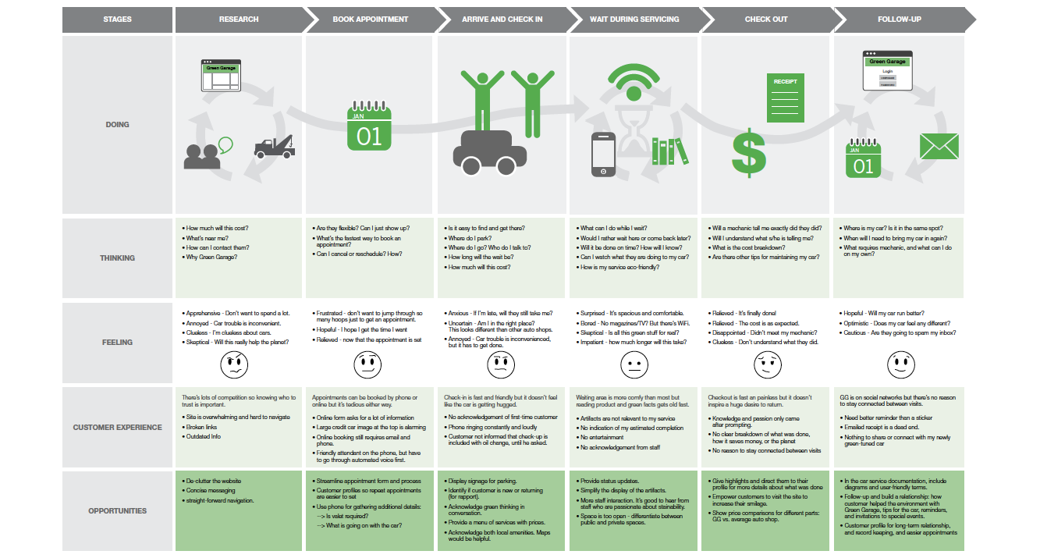

Figure 4 Example of a filled-out Customer Journey (source: https://uxplanet.org/)

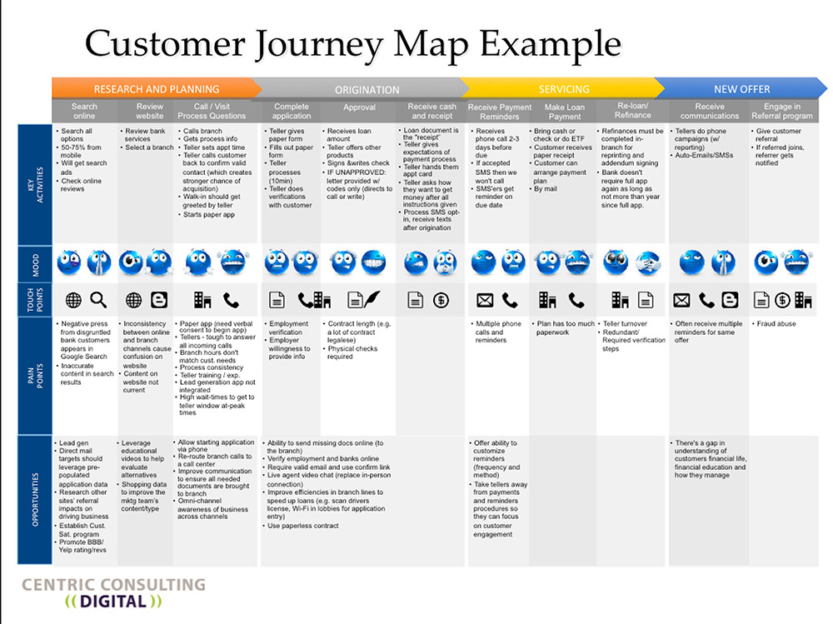

Figure 5 Example of a Customer Journey Map (source: https://centricconsulting.com)

|  |  |  |  |  |  |  |  |
| --- | --- | --- | --- | --- | --- | --- | --- |
| **Stages:** | Getting information  Preparing | **Buy**  Purchase | Deliver | **Use**  Consume | Add-ons  Supplements | Maintenance | Disposal |
| Doing |  |  |  |  |  |  |  |
| Thinking |  |  |  |  |  |  |  |
| Feeling  Experience |  |  |  |  |  |  |  |
| Front end  Touchpoints |  |  |  |  |  |  |  |
| Back end  Infrastructure |  |  |  |  |  |  |  |
| Customer Pains Opportunities |  |  |  |  |  |  |  |

* 1. Servitization opportunities

|  |  |
| --- | --- |
| **The second phase ends with the formulation of the servitization concept. If there are more opportunities, they should be defined and assessed. The assessment is based on the insights gained from more detailed analysis of the customer segment, pain points identified during customers journey and eventually feedback gained from direct interactions with the customers.**  **The framework used is: customer related advantages (importance and relevance) and general attractiveness for the company (possibility and profitability).** | |
| **Guidelines on implementation:** | **D.T1.3.1 - Phase 2 – Workshop** |

Based on the insight and acknowledgments on external developments and customer behaviour acquired by using the proposed tools, servitization opportunities can be formulated and evaluated. Evaluation should be performed based on both the customer’s and the company’s perspective so it can be assessed if the opportunity presents important solution for the customer while also a significant value for the company.

Assessment of customer experience with a certain product should provide details on problems that arise during the customer journey. These problems and needs should be described along with evaluation of their importance for the customer.

Any idea for a new additional service or transformation of the product into a service, incremental improvements or radical initiatives, should be:

* Named (if possible) and briefly described

And assessed from:

* The customer perspective (Not just how the participants from the company think based on the experience and previous relations, but also based on the detailed assessment of customer segment through interaction with the customers during Phase 2):
  + Is it important for the customers?  
    Will it create substantial benefits for the customers? Will customers experience tangible benefits from additional services?
  + Unsatisfied customer problem  
    Do customers have unsolved problem during our product lifecycle? Is it important for the customers? Do we get a lot of complaints regarding it?
* The company perspective and its existing way of doing business, competences, organisational capacity, values and beliefs, etc.:
  + Is it doable?   
    Is it possible to implement it with acceptable level of effort and investment? Within manageable timeframe?
  + Is it financially sound - lucrative?  
    Are there great number of customers with that problem and purchasing power and willingness to pay?

**High value opportunities**

|  |  |  |  |  |  |
| --- | --- | --- | --- | --- | --- |
| **Opportunity**  What customer want?  Or think that is important?  (description of a problem or challenge customer face while buying and using our product) | Customer perspective | | Commercial – business perspective | | Opportunity |
| **Important for customers**  Creation of substantial customer benefits which are considered to be relevant and important. | **Unsatisfied customer problem**  Appropriate solution to unsolved problems, risks or damages; Superior to available solutions or previously underserved or excluded customers. | **Doable and scalable**  Possible to implement with acceptable level of effort and investment; Having a substantial growth potential. | **Valuable and lucrative**  Great number of customers with purchasing power and willingness to pay; Customers identified in different and unrelated markets. |
| A  1min-5max | B  1min-5max | C  1min-5max | D  1min-5max | A+B+C+D |
|  |  |  |  |  |  |
|  |  |  |  |  |  |
|  |  |  |  |  |  |
|  |  |  |  |  |  |

* 1. Prioritized Opportunities (Company Perspective)

|  |  |
| --- | --- |
| **At the end of the second phase, if there is more than one, key opportunities should be compared and evaluated in terms of their applicability, feasibility and sustainability. Most promising opportunity will be formulated into initial servitization concept.**  **Previous prioritization of the opportunities was assessing opportunities – their market and industry perspective. Opportunity that has great potential in general might not be appropriate for the particular company – final assessment should be done from the perspective of the company and its capabilities to perform and implement.** | |
| **Guidelines on implementation:** | **D.T1.3.1 - Phase 2 – Workshop** |

After identifying different opportunities and possibilities to improve customer experience and their relation with the ”industry”, certain features of those that are the most interesting need to be defined and assessed from the company perspective. It needs to be understood which possible actions and improvements will have the greatest market and financial impact, while not being too demanding resource-wise and disruptive for the organisation’s every day’s business.

Previously identified opportunities are confronted with pilot company specifically defined solutions that are expected to address the identified particular opportunity.

Those company specific solutions for the most appealing opportunities formulated during previous steps shall be evaluated based on the same criteria:

* **Investment level -** Level of the investment needed for opportunity related servitization implementation.
* **Effort and time -** Expected duration, manpower use and total effort needed from the perspective of the existing workload and workforce capabilities; Complexity and scope of new employment, organizational change and adaptation.
* **Market risk -** Clear understanding of the needs of the accessible market, willingness to pay, size of the pilot actions and market testing and introduction efforts.
* **Technology risk -** Available technologies and implementation challenges, technology maturity and robustness, is it already in standard use or still in development, need for additional certification or industry standards adjustment etc.
* **Change level** - General need for transformation of the organization, distribution channels, new partnerships, scalability level (0,1x, 1x; 10x), access to new markets or different industries/value chain elements, cultural differences etc.

Opportunities with the lowest score are the easiest to implement and the result has to be compared with previously identified impact potential to identify opportunity with highest potential for reward with lowest challenge level.

|  |  |  |  |  |  |  |  |
| --- | --- | --- | --- | --- | --- | --- | --- |
| **Customer related opportunity** | **Company’s solution** | **Investment level**  1min-5max | **Effort and time**  1min-5max | **Market risk**  1min-5max | **Technology risk**  1min-5max | **Change level**  1min-5max | **Score**  sum |
|  |  |  |  |  |  |  |  |
|  |  |  |  |  |  |  |  |
|  |  |  |  |  |  |  |  |
|  |  |  |  |  |  |  |  |
|  |  |  |  |  |  |  |  |

* 1. Servitization concept

|  |  |
| --- | --- |
| **Key output of the second phase is the initial servitization concept – a brief description (or few of them) of the new service that will be complemented to the product chosen for the servitization initiative.**  **The aim is to identify key elements that are crucial for the implementation and to enable understanding of the organizational and operative changes that will be envisioned during the next steps.** | |
| **Guidelines on implementation:** | **D.T1.3.1 - Phase 2 – Workshop** |

To sum up previously developed knowledge, insights and ideas, the second phase ends with the initial servitization concept which consists of:

* **Servitization idea tagline** – title or short description of the servitization initiative,
* **Service description** – full description of services that will be added or that will substitute particular elements of existing product offering,
* **Customer experience description** – service seen from the customer perspective (perception, timeline, sequence),
* **Service outcome description:** ***benefits*** – additional gains; ***emotions*** - what and how will customers feel; ***value*** – key elements of the value proposition,
* **Organizational aspects**
  + Human and other resources needed (what does company need to develop and to implement service in full),
  + Processes (new or alterations of existing activities; which activities should be included in the existing business),
  + Structure – organizational and hierarchical (transformations in information exchange and decision-making hierarchy),
  + Key performance indicators, main goals and outputs (key goals, performance indicators to measure and manage),
* **Responsibilities and management elements**
  + Key creation and development responsibilities (who will develop and “install” new services),
  + Implementation / commercialization responsibilities once the service is up and running (who will be in charge when the servitization initiative is “up and running”).

**Servitization concept**

|  |  |  |  |
| --- | --- | --- | --- |
| Key idea: | | | |
| Service description | | | |
| Service experience | | | |
| Benefits | Emotions | | Value |
| Organizational aspects | | | |
| Development responsibilities | | Implementation / commercialization responsibilities | |

1. The delivery month settled in the approved Application Form (February 2019) has been postponed upon decision of the Project Management Board to improve the quality of the deliverable. The delay did not have any negative effect on the project implementation.